BAE SYSTEMS Missile Freight Service

Background
BAE SYSTEMS is constantly monitoring the dynamic global marketplace in pursuit of new business thrusts. One potential area for growth is in high-speed, low-cost freight delivery systems, because it will be imperative for American businesses to satisfy customer needs by rapidly responding to orders. Existing surface transportation (ship, rail, and truck) is slow, and aircraft, although somewhat faster, have considerable crew and maintenance expenses. A vision has been developed for fulfilling this transportation need with low-cost, unmanned missiles. With the declining defense market, this new venture provides an excellent opportunity to leverage BAE SYSTEMS expertise into new fields of business.

Investigation
It is necessary to evaluate the technical feasibility of this concept before making significant commitments of capital. Consequently, it is desired to analyze the performance of such a system. Because New York and Los Angeles represent the two largest markets in the US, they will be the focus of the preliminary technical study. A preliminary analysis is needed to specify technical requirements for a missile flying form New York to Los Angeles.
A ballistic missile flight consists of two principal phases, boost and ballistic. In the boost phase, the missile is powered. Once mission-dependent conditions are met, missile thrust is terminated, and the missile then enters the ballistic phase, during which the missile is allowed to fall freely to its destination. In a commercial missile application, it is essential to keep costs low, while meeting performance requirements. Therefore, a minimal amount of steering and control will be done, and a trajectory will be designed to minimize fuel consumption, since reducing fuel weight increase cargo capacity. Because the missile has essentially constant thrust, a shorter boost phase consumes less fuel. Consequently, it is necessary to analyze the characteristics of a missile flight from New York to Los Angeles, determining the initial launch orientation, minimum necessary velocity, time of flight, and thrust cutoff time (corresponding to fuel consumption).
To ensure that the results are meaningful, a preliminary analysis should consider these effects:
- The earth is round.
- The magnitude of gravity depends on the distance from the earth
- The missile has zero initial velocity, and it accelerates to its cutoff velocity.
Further effects, suitable for discussion and further analysis, are as follows:
- The earth rotates.
- The missile experiences aerodynamic drag.
- The density of the atmosphere varies with distance from the earth.

Approach
The basic equations of motion are
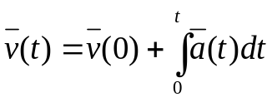 | (1)
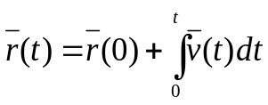, | (2)
where a, v, and r represent the missile’s acceleration, velocity, and position in the same arbitrary coordinate frame. However, these deceptively simple equations quickly become complicated because there is no single coordinate frame that is right for the job, and working with different frames reveals inter-dependencies among acceleration, velocity, and position. For example, navigation is best performed in an inertial (non-moving) frame, but the missile destination lies on an earth-fixed frame. Acceleration depends on gravity, and on thrust and drag, which are modeled in a missile body frame. However, drag in turn depends on inertial velocity and earth-fixed atmospheric characteristics. In addition, transformation between inertial and body frames depend on missile velocity in an inertial frame.
Because of these complexities, it is not possible to develop simple closed-form solutions to the equations of motion, and some numerical scheme must be used. A fourth-order Runge-Kutta technique shall be used, and it is desirable to develop a highly modular computer simulation with subroutines that can accommodate the repeated computations required for each iteration.
Rather than immediately producing a large simulation with all the effects modeled, it will prove more proactive to utilize a “building block” approach. This method offers the advantages of providing insight, assuring that results still make sense as the models get more complex, and helping evaluate the contributions of individual effects. The approach begins with simple hand analyses, progresses to a numerical technique that duplicates the hand analysis, and then adds more complexities in an orderly fashion.
Each missile simulation should:
- Start the missile at a given elevation at the launch point
- Apply thrust and terminate thrust in the specified manner
- Keep track of the missile and target coordinates and height of the missile
- Verify that the missile reaches its destination
- The thrust cutoff time (Step #4)

Analysis Step #1 – Flat Earth

For this step, make the following assumptions:
- The earth is flat and does not rotate.
- Gravity is constant.
- Aerodynamic effects are neglected.
- All thrust is applied instantaneously at launch, providing an initial missile velocity.
Using these assumptions, the trajectory analysis reduces to a two-dimensional problem.

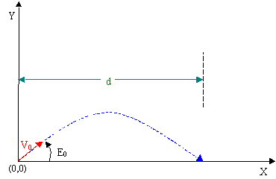
Figure 1. Diagram of the two-dimensional problem.
As seen in Figure 1, we can use an X-Y coordinate system, where X represents the horizontal component of missile flight, and Y represents the vertical component of missile flight. E₀ is the launch angle, V₀ is the initial missile velocity, and d is the horizontal distance traveled. In this coordinate system, gravity will only act in the Y direction.
Straightforward hand analysis can be used to provide a quick estimate of the mission parameters, which can then be refined by computer analysis. Because the initial velocity and gravity are constant, it is possible to develop simple first and second order expressions for horizontal and vertical position as a function of time. Derive these expressions, and solve for the following:
- The launch angle that minimizes the required initial launch velocity.
- The minimum necessary velocity
- The resulting time of flight.
To develop an understanding of the numerical process that will be used in future steps, duplicate your hand-analyses using a fourth-order Runge-Kutta method of numerical analysis.

Analysis Step #2 – Curved Earth

For this step, make the following assumptions:
- The earth is curved and does not rotate.
- Gravity is constant and always acts perpendicular to the surface of the earth.
- Aerodynamic effects are neglected.
- All thrust is applied instantaneously at launch, providing an initial missile velocity.
Since the earth is not flat, the Y-axis is tangent to the earth’s surface and does not intercept the target as seen in Figure 2. Therefore, the vector between NY and LA is no longer just the arc distance between the two cities. It is now the linear distance between the cities. Also, because the earth is now round, the acceleration due to gravity is not constant in the X-Y coordinate system. Instead, gravity always acts perpendicular to the surface of the earth.
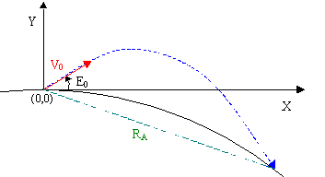
Figure 2. Diagram of the curved earth simulation.
Considering the assumptions, modify your previous missile simulation to solve for the following values:
- The launch angle that minimizes the required initial launch velocity.
- The minimum necessary velocity
- The resulting time of flight.
To modify this simulation, you will need to compute the orientation of the gravity vector relative to your coordinate system, and then compute its components in the axis directions. To accomplish this, it may be helpful to compute the height of the missile above the surface of the earth. Note that for this geometry, the launch angle is defined with respect to the surface of the earth and not the launch-target vector. The flight of the missile ends when it strikes the earth’s surface, i.e. when the height above the surface is zero. For the missile to reach its target, its coordinates at zero height must equal the coordinates of the target. Consequently, it will also be necessary to determine the target coordinates relative to your coordinate system. In order to determine the target coordinates, it may be helpful to analyze the following geometry in Figure 3. It shows one method of determining the target’s coordinates in the X-Y coordinate system using the law of sines where R_{A} is the linear distance from NY to LA and R_{Earth} is the radius of the earth.
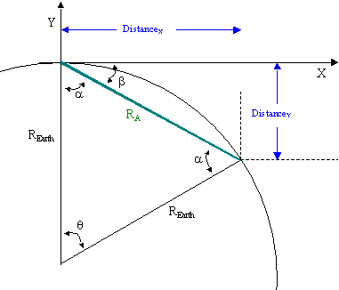
Figure 3. Geometry to determine the coordinates of a desired target point.
Important Note: The choice of coordinate system is up to you. Step #2 (as well as Steps #3 and #4) can be solved using any valid coordinate system. However, you must take care to ensure that you correctly apply the coordinate system you select. For example, a Cartesian coordinate system (x,y) corresponds to a fixed coordinate frame (which makes gravity more difficult to characterize). Each of the unit vectors pointing in the x-direction and the y-direction are independent of the position of the missile. On the other hand, a polar coordinate system (which makes gravity simpler to characterize) corresponds to a relative coordinate frame. Each of the unit vectors pointing in the r-direction and the φ -direction are dependent on the position of the missile. What this means is that the vector derivatives of and are not obtained simply by computing the scalar derivatives of r and φ. The correct velocity vector derivative is obtained via the following:
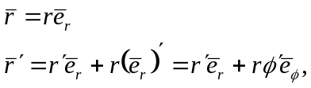
meaning that
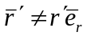.
To say this one more way, do not treat the (r, φ) coordinate system like you would the (x,y) coordinate system.

The acceleration vector can be obtained by differentiating the above velocity vector.

Analysis Step #3 – Changing Magnitude of Gravity
For this step, make the following assumptions:
- The earth is curved and does not rotate.
- Gravity varies inversely with the square of the distance from the center of the earth and always acts perpendicular to the surface of the earth.
- Aerodynamic effects are neglected.
- All thrust is applied instantaneously at launch, providing an initial missile velocity.
Considering the assumptions, modify your previous missile simulation to solve for the following values:
- The launch angle that minimizes the required initial launch velocity.
- The minimum necessary velocity
- The resulting time of flight.

Analysis Step #4 – Adding Missile Thrust
For this step, make the following assumptions:
- The earth is curved and does not rotate.
- Gravity varies inversely with the square of the distance from the center of the earth and always acts perpendicular to the surface of the earth.
- Aerodynamic effects are neglected.
Instead of having an instantaneous initial velocity, the missile actually has a constant thrust (acceleration) that is applied for a specific time and then terminated. For this analysis it is sufficient to assume that the thrust is constant in magnitude and direction. Its direction is the same as the initial launch orientation of the missile.
Considering the assumptions, modify your previous missile simulation to solve for the following values:
- The launch angle that minimizes the required initial launch velocity.
- The minimum necessary velocity
- The resulting time of flight.
- The thrust cutoff time, assuming the missile accelerates at constant thrust to achieve the required launch angle.

Results
Prepare a table of results comparing launch elevation, minimum necessary velocity, time of flight, and (for #4) thrust cutoff time for each level of analysis performed. Comment on the effects of each level of upgrade to the analysis. Then evaluate the sensitivity of the system performance to the assumptions used to generate launch requirements by tabulating the impact error (miss distance) when the initial conditions derived for each model are used to “fly” the missile with models more accurate than those used to generate the requirements.
Model Characteristics | Launch Requirements
Model Characteristics | Elevation Angle | Cutoff Velocity | Time of Flight | Cutoff Time
Step #1 - Flat Earth |  |  |  | N/A
Step #2 - Curved Earth |  |  |  | N/A
Step #3 - Change Magnitude of Gravity |  |  |  | N/A
Step #4 - Adding Missile Thrust

If time permits, use the final simulation to determine sensitivity of fuel consumed to launch angle, so that a minimum-fuel trajectory can be selected.

